**Navigating around R Studio**

Open R Studio

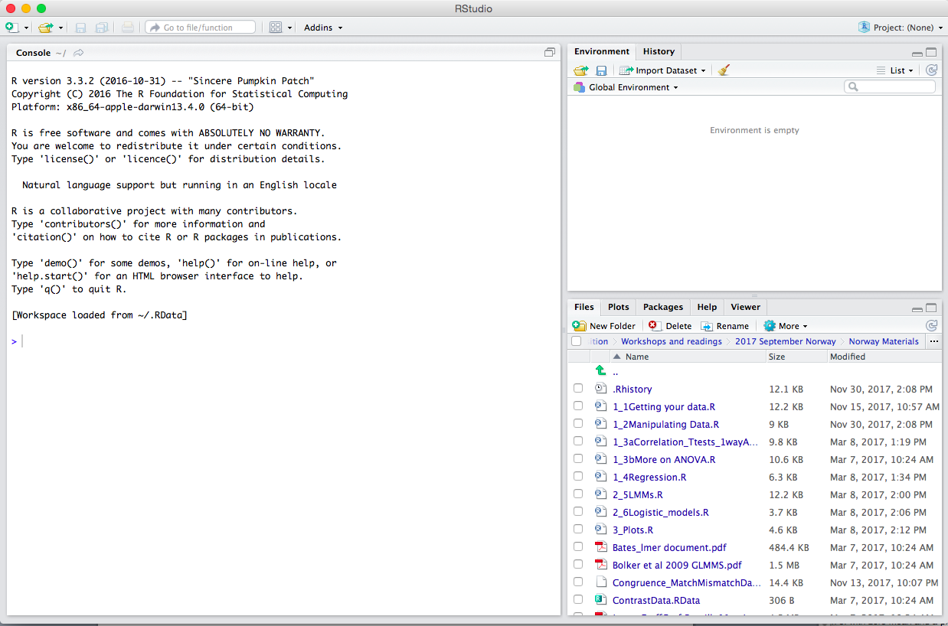



Click three dots to navigate to folder

Use brush to clear previous work   
(if not using)

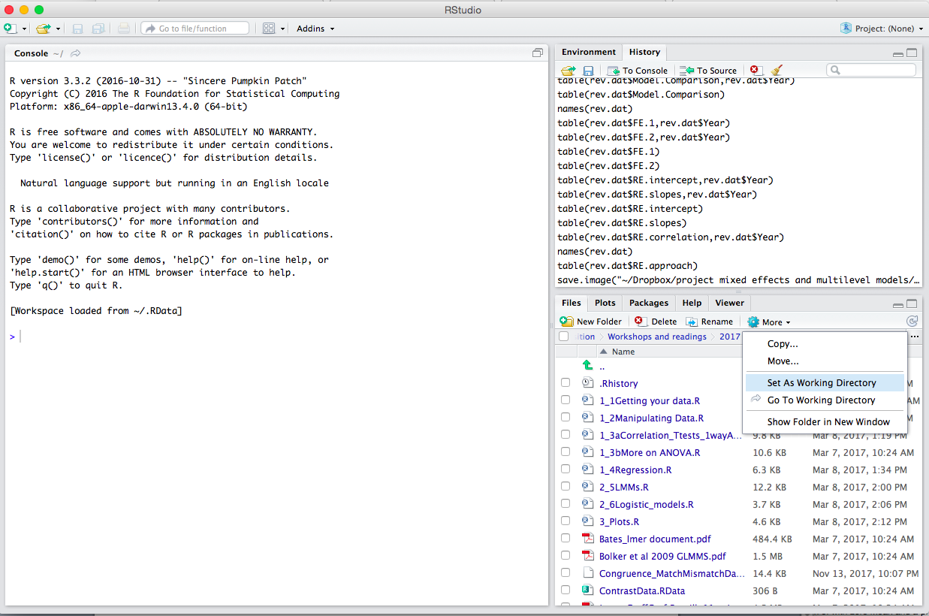

Once in the correct folder, ***always***Set As Working Directory

To load a previous set of data / analysis, got to Session, Load Workspace.  
Then select the Workspace file you want from the folder you are in (the working directory).

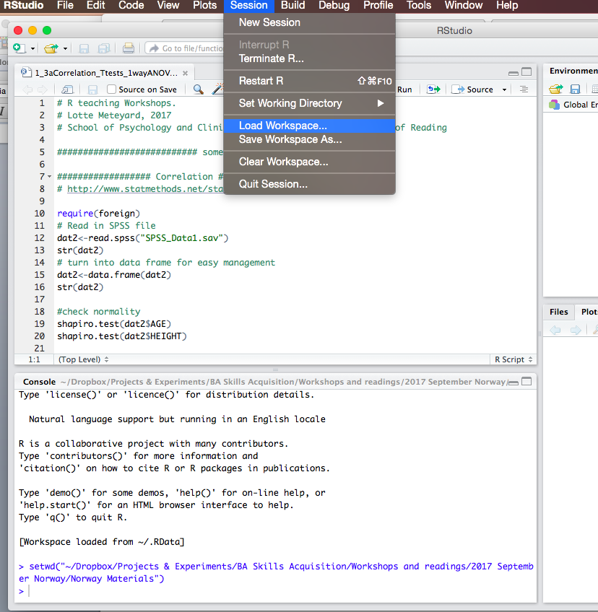

Once you have loaded a Workspace, you will see the data appear in Environment

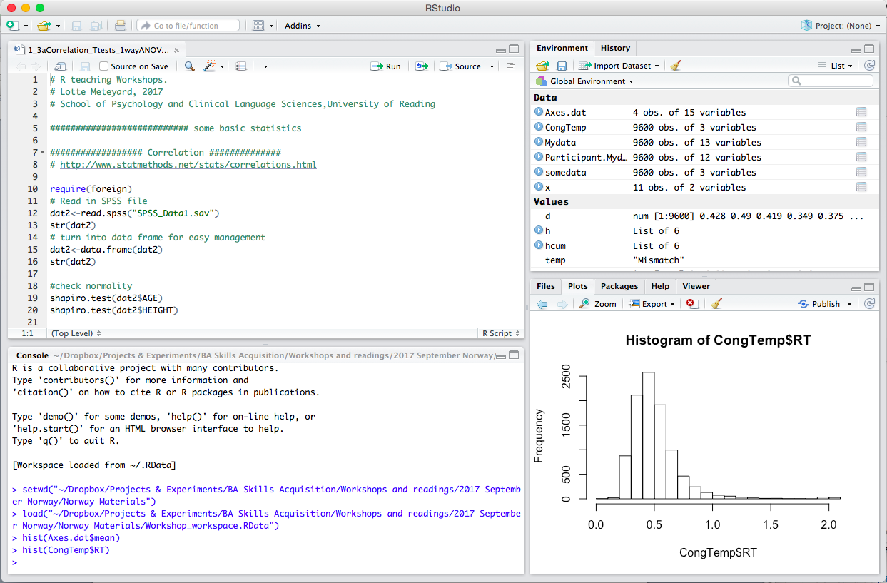

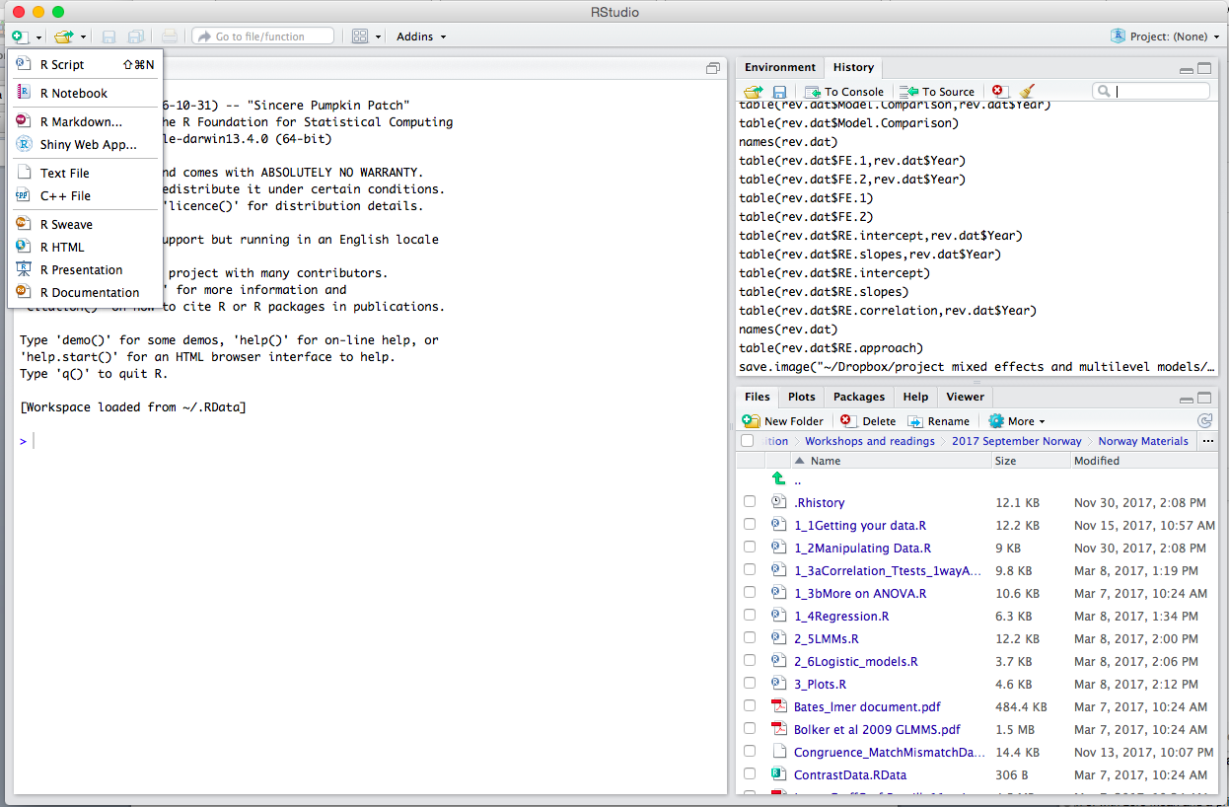

To see your previous commands go to History

To create a new scripting file, you can use the symbol in the top right (small green cross).



To open an existing Script file, click on the folder symbol and choose the file you want, from the folder you are in (your working directory). It will then appear in the top left part of the screen.





Figures will appear in the plots window

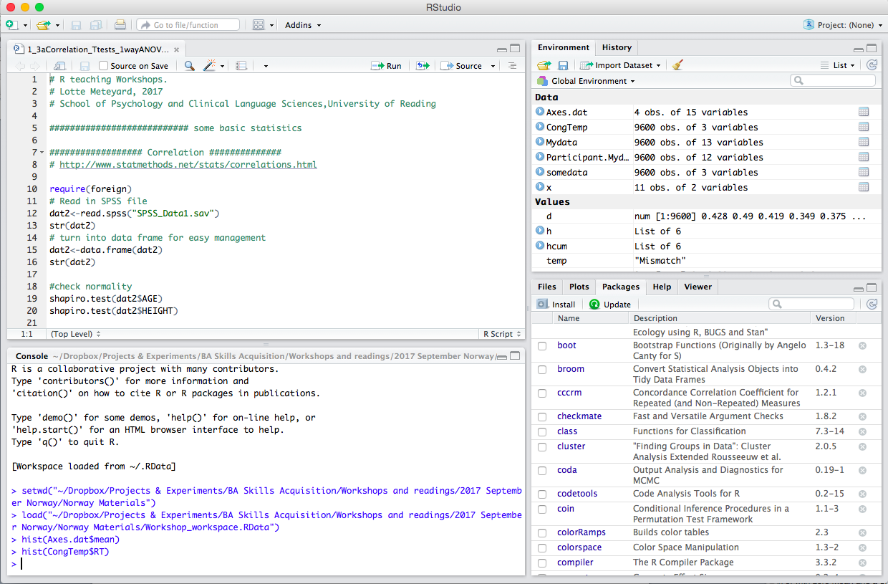

You can see a list of packages/add ons you have in the Packages window

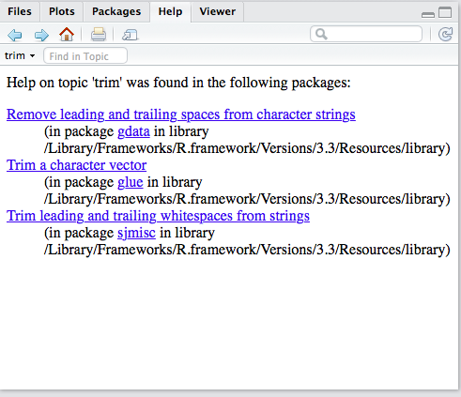

Help and details for specific functions and packages will appear in the Help window